**Date and Time functions**

**1. Write a query to display the first day of the month (in datetime format) three**

**months before the current month.**

**Sample current date : 2014-09-03**

**Expected result : 2014-06-01**

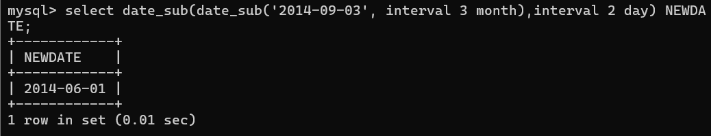

**2. Write a query to display the last day of the month (in datetime format) three**

**months before the current month.**

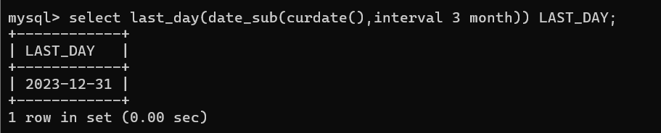

**3. Write a query to get the distinct Mondays from hiredate in emp tables.**

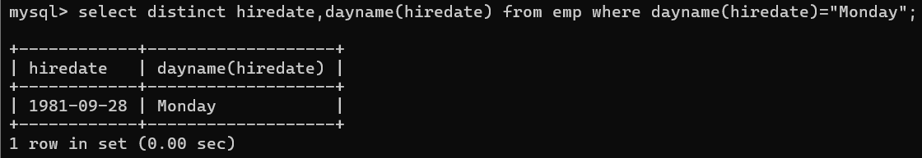

**4. Write a query to get the first day of the current year.**

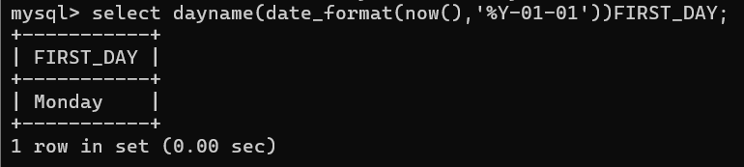

**5. Write a query to get the last day of the current year.**

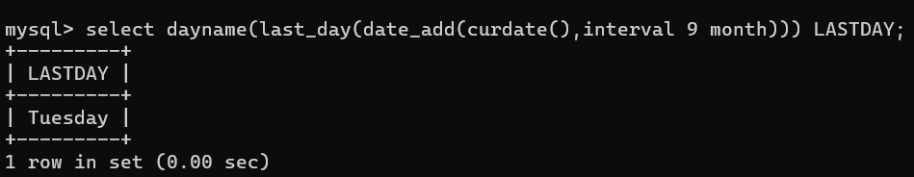

**6. Write a query to calculate your age in year.**

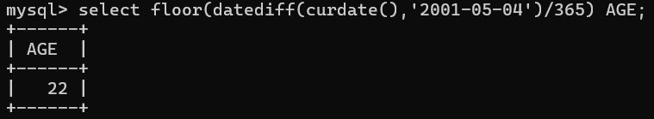

**7. Write a query to get the current date in the following format.**

**Sample date : 04-sep-2014**

**Output : September 4, 2014**

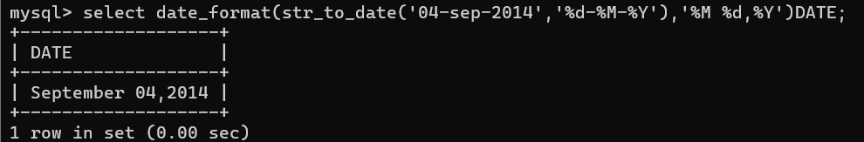

**8. Write a query to get the current date in Thursday September 2014 format.**

**Thursday September 2014**

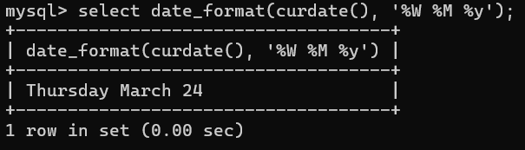

**9. Write a query to extract the year from the current date.**

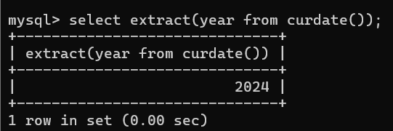

**10. Write a query to get the first name and hire date from employees table**

**where hire date between '1987-06-01' and '1987-07-30'**



**11. Write a query to display the current date in the following format.**

**Sample output: Thursday 4th September 2014 00:00:00**

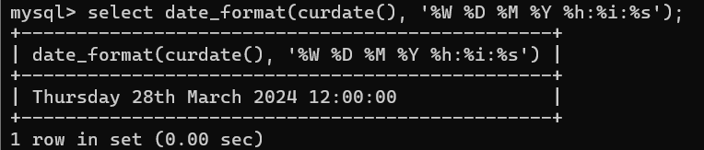

**12. Write a query to display the current date in the following format.**

**Sample output: 05/09/2014**

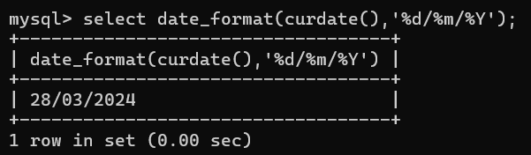

**13. Write a query to display the current date in the following format.**

**Sample output: 12:00 AM Sep 5, 2014**

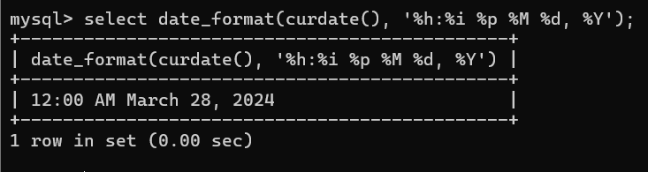

**14. Write a query to get the employees who joined in the month of June.**

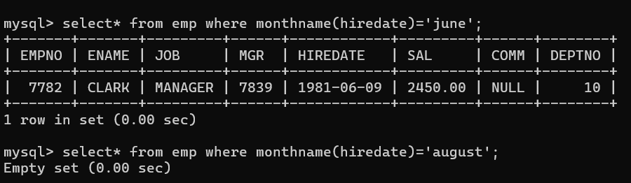

**15. Write a query to get the years in which more than 10 employees joined.**

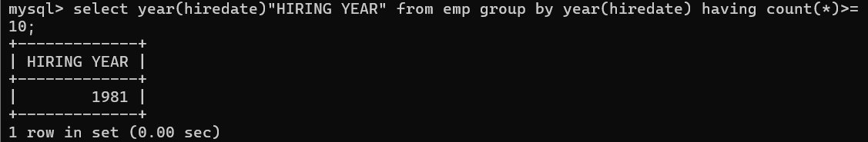

**16. Write a query to get first name of employees who joined in 1987.**

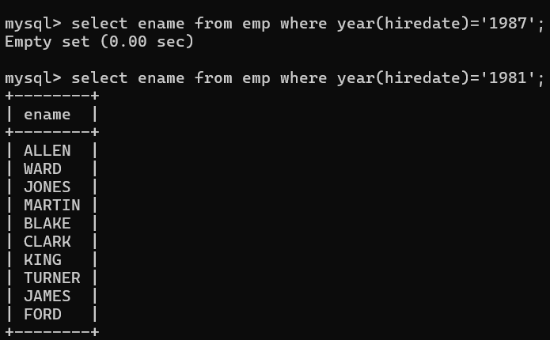

**17. Write a query to get employees whose experience is more than 5 years.**

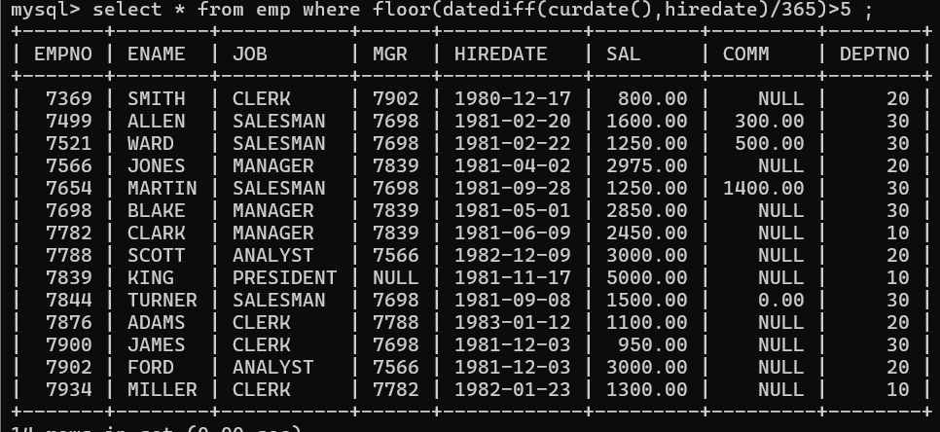

**18. Write a query to get employee ID, last name, and date of first salary of the**

**employees.**

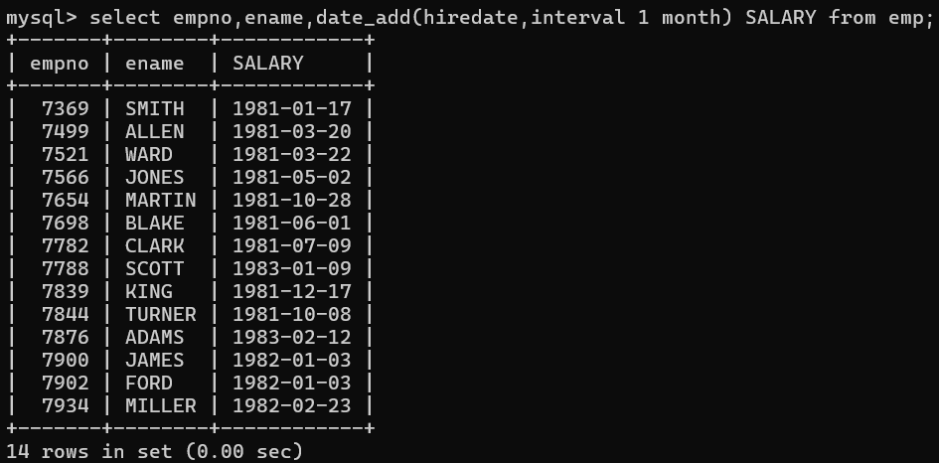

**19. Write a query to get first name, hire date and experience of the**

**employees.**

**Sample table: employees**

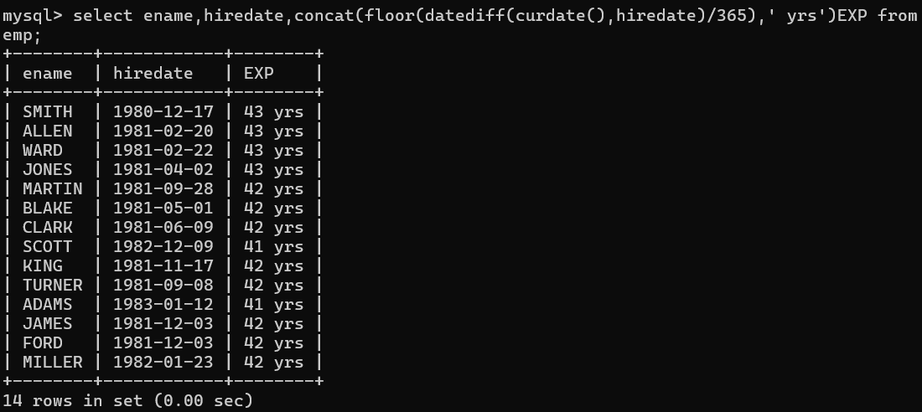

**20. Write a query to get the department ID, year, and number of employees**

**joined.**

